AI Agent for Documentation and Summation

Midterm Requirements Model

Version 3.0

Team Members

Shar Min
Abhisar Anand
Brayan Cano
Myles Edwards
Ali Mutlek
Dhyan Patel

Revision History

Date | Version | Description | Name
11/7/2025 | 1.0 | First draft | Shar Min
12/10/2025 | 2.0 |  | Shar Min

Product Increment Summary

The AI Agent for Documentation and Summation project has made strong progress since the midterm report. The current version of the system includes a working speech-to-text pipeline powered by OpenAI’s Whisper model, which can take recorded speech and convert it into written text with reliable results.

Since the midterm, the system has advanced significantly. The team successfully integrated speech diarization using Pyannote, implemented automatic PII redaction, added LLM-based SOAP note generation, and built a working session history so users can revisit past conversations. A full end-to-end pipeline is now functional, allowing users to record audio, upload recordings, process them through Whisper and Llama3 LLM for redactions, and summaries directly on the dashboard.

The prototype currently runs on local development machines, including a Linux CPU server. These environments support Whisper, Pyannote, and the LLM pipeline for summarization. MongoDB continues to store transcripts, summaries, OCR results, and session metadata as users interact with the system.

OCR functionality is fully implemented for typed documents and operates as an active feature in Version 1 of the system. Handwritten OCR remains a possible enhancement for future versions depending on project scope and available resources.

Functional Requirements

1. Audio Input
- The system must allow users to record audio directly from the web application.
- The system must allow users to upload existing audio files.
2. Speech-to-Text Transcription
- The AI model Whisper must convert speech into written text.
- The system must support multi-speaker audio.
3. Speaker Diarization
- The AI model Pyannote must identify which speaker is talking in the audio.
4. OCR Processing
- The system must scan and extract text from typed documents (images or PDFs).
- OCR results must be stored and viewable in the dashboard.
5. PII Redaction
- The system must automatically hide or replace personal identifiable information (PII) in transcripts before display or storage.
6. LLM Summarization
- The system must generate short, structured SOAP-format notes using a Large Language Model (LLM).
- The summary must be linked to the processed transcript for viewing and download.
7. Session History
- The system must save previous sessions so users can reopen transcripts, redacted text, and SOAP notes later.
8. Data Storage
- The system must store transcripts, summaries, redacted text, session metadata, and OCR outputs in MongoDB.
9. Dashboard Display
- The web dashboard must display transcripts, speaker labels, summaries, and OCR results.
- Users must be able to log in and view only their authorized data based on their role.
10. Multi-Input Support
- The system must support both audio inputs and document inputs.
11. Backend Processing
- All AI processing (Whisper, Pyannote, LLM summarization, OCR, redaction) must be executed on the local development server (Linux CPU machine).
12. Role-Based Transcript Visibility
- Admins view redacted transcripts; doctors and patients view full transcripts.
13. Authentication System
- The system provides secure login and role-based authorization.
14. Admin Dashboard
- Admins can view all system sessions and user activity.
15. Patient Portal
- Patients can only view their own session summaries.

Non-Functional Requirements

1. Usability
- The system should be easy to use and understandable for doctors, assistants, and students.
- The dashboard interface must be clean, responsive, and simple.
2. Performance
- Current prototype performance depends on CPU.
- The system should process a 1-5 minute live audio within a reasonable time for a demo environment.
- (Future Goal) With GPU deployment, processing should target < 1 minute
3. Security
- The system must follow HIPAA-aligned practices by redacting PII before displaying or storing transcripts.
- All data stored in MongoDB should be protected with authentication and secure access.
4. Reliability
- The system should run safely on local servers without crashing during audio uploads or processing.
- The dashboard should respond within a few seconds for standard navigation and viewing results.

5. Accuracy
- Whisper transcription should meet expected accuracy for conversational audio.
- OCR should correctly extract typed text from scanned documents.
6. Scalability
- The system should support multiple users uploading data sequentially or concurrently.
- Architecture must allow future scaling to a GPU server or maybe cloud deployment.
7. Compatibility
- The system must work on major browsers: Chrome, Firefox, and Edge.
- The web app must function on desktops and laptops without needing installation.
8. Data Integrity
- All user data must be stored without corruption and be retrievable in session history.
- Summaries and transcripts must match the corresponding audio input.
9. Security & Access Control”
- Only authenticated users can access transcripts, summaries, and OCR data.
10. Local Resource Constraints
- System performance is limited by CPU and RAM availability.

Product Backlog

- Audio Recording (Real-time streaming transcription)
- Speaker Diarization
- OCR Scanning and Text Extraction
- SOAP-Format Summarization
- Dashboard Design
- AI Server (receives audio and converting speech to text, and speech diarization, and creating SOAP summaries)
- HIPAA Redaction and Security
- GPU server for future development (not available currently) and SSH Access
- Llama3 summarization
- Llama3 redaction
- Login system
- Session history
- Role-based access
- Admin dashboard
- Patient portal
- Diagnostic accuracy improvements

User Stories
- Doctors want to record their patient’s conversation so it can get automatic receive a transcript, and written notes (SOAP note).
- Medical assistants want to upload scanned medical forms so the system can read and summarize them.
- As a developer, we want to connect to the CPU/GPU computer remotely so it can run and test the AI models faster.
- Admins can view all user sessions and mange system records.
- Patients can log in and view only their own visit summaries

Use Case:

General System Overview

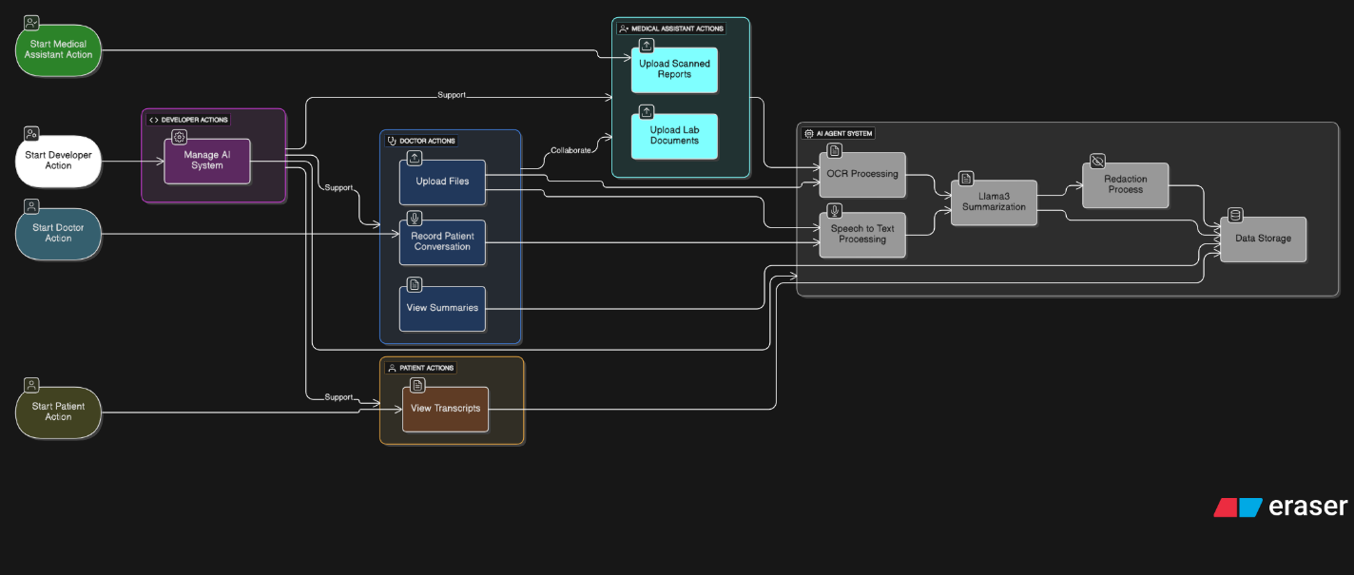

- The doctor can record a patient conversation, upload files, and view summaries.
- The medical assistant can upload scanned reports or lab documents for OCR processing.
- Patients can only view their transcripts.
- The developer manages the technical side, like making sure the AI system runs properly.
- All of these actions connect to the AI Agent System, which handles speech-to-text, Llama3 LLM summarization and redaction, and data storage.

Audio Recording and Summarization

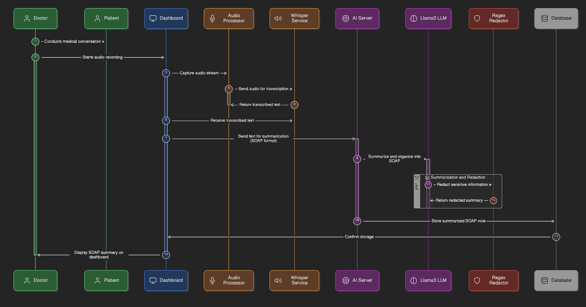

- The doctor records a conversation with a patient in real working dashboard (not Figma)
- The system uses Whisper to change that audio into written text.
- Then the text is sent to AI Server to run the Llama3 LLM locally for summarization, which organizes it into the SOAP format (Subjective, Objective, Assessment, and Plan).
- Llama3 + regex for redaction.
- The summarized data is stored in the database and shown on the dashboard.

Document Upload and OCR Extraction
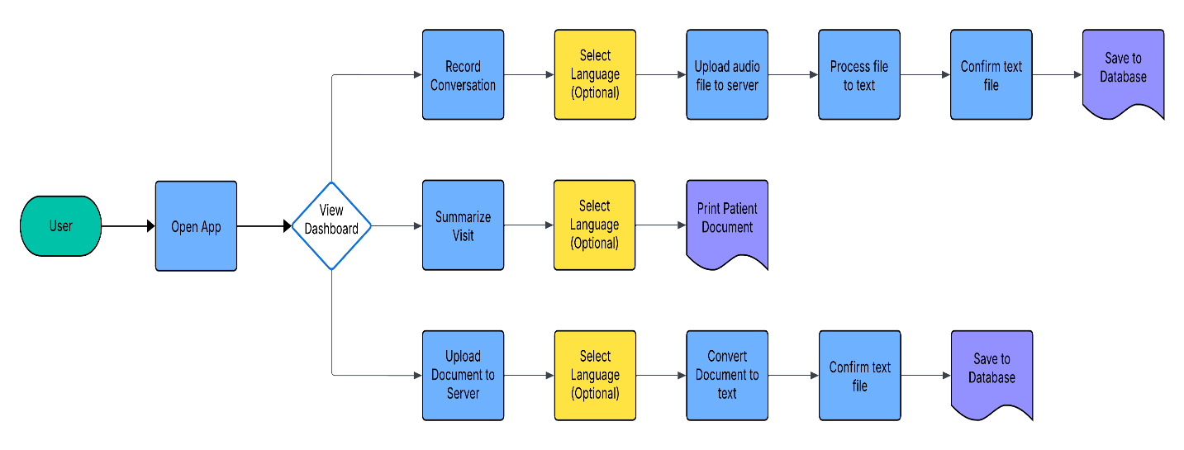
- The medical assistant or user uploads a scanned or image file.
- The OCR reads and pulls the text from the file.
- The text is cleaned, checked, and stored in the database.
- The dashboard lets the doctor or assistant view the extracted text or print a summary.

